**GS Project**

**S M Sadman Sakib Sayor  
KAC25U , Computer Science**

**#Requirement of projects according to E-learning:**

**1. When preparing your**[**project**](https://elearning.unideb.hu/mod/assign/view.php?id=277170)**work, be sure to include the following in your documentation, outlining the most important steps and settings related to them.**

**2. Modelling - use at least five different basic object modelling operations/transformations**

**3. Appearance - setting the material,**[**texture**](https://elearning.unideb.hu/mod/resource/view.php?id=277167)**(at least assigning a base colour)**

**4. Animation - by specifying [keyframes](https://elearning.unideb.hu/mod/url/view.php?id=277156" \o "Keyframes) on the timeline, using follow**[**path animation**](https://elearning.unideb.hu/mod/url/view.php?id=277157)**, optional: physical simulation, character animation (using at least two different methods)**

**5.** [**Scripting**](https://elearning.unideb.hu/mod/url/view.php?id=277169)**- writing and using your own Python script (e.g. to automate certain steps)**

**6. Rendering - settings, experiences**

**Video links used in this Project:**

1. **For making the Walker**   
   [**https://www.youtube.com/watch?v=imbIsNAvUpM**](https://www.youtube.com/watch?v=imbIsNAvUpM)
2. **For making the mirror**[**https://www.youtube.com/watch?v=SLChjoLf5jg**](https://www.youtube.com/watch?v=SLChjoLf5jg)
3. **For making the treadmill**[**https://www.youtube.com/watch?v=OhzcCsR_EO0**](https://www.youtube.com/watch?v=OhzcCsR_EO0)
4. **For making studio lighting Set up**[**https://www.youtube.com/watch?v=CCmV1X8t2SQ&t=43s**](https://www.youtube.com/watch?v=CCmV1X8t2SQ&t=43s)
5. **For making glow compositor Set up**[**https://www.youtube.com/watch?v=5OSjvlUddoM**](https://www.youtube.com/watch?v=5OSjvlUddoM)

**Start of my project by deleting the cube**

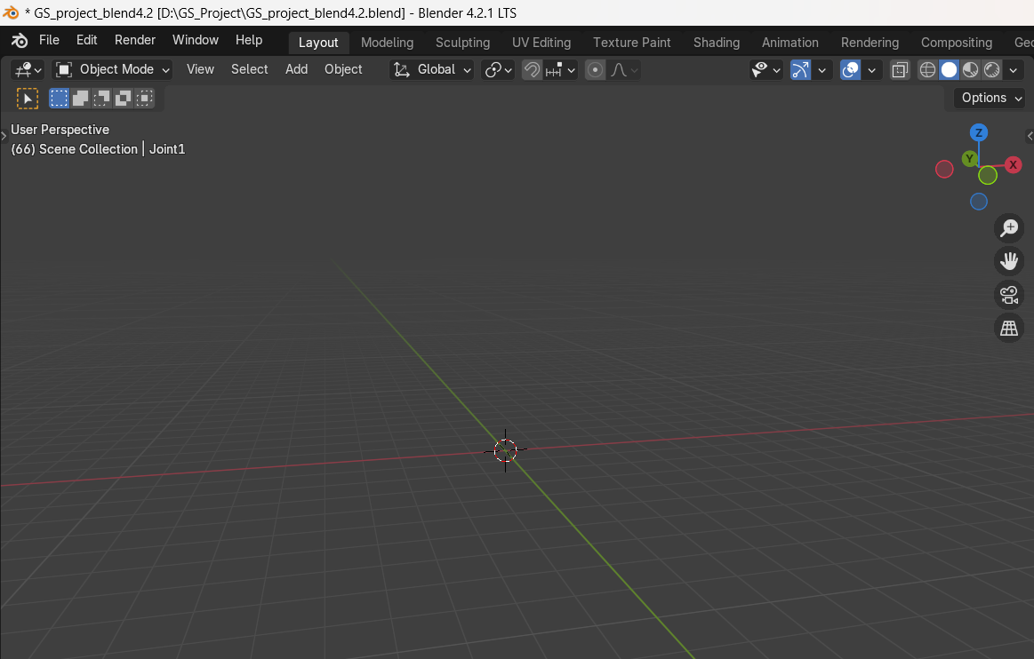

**Zeroth Step:  
Creating a plane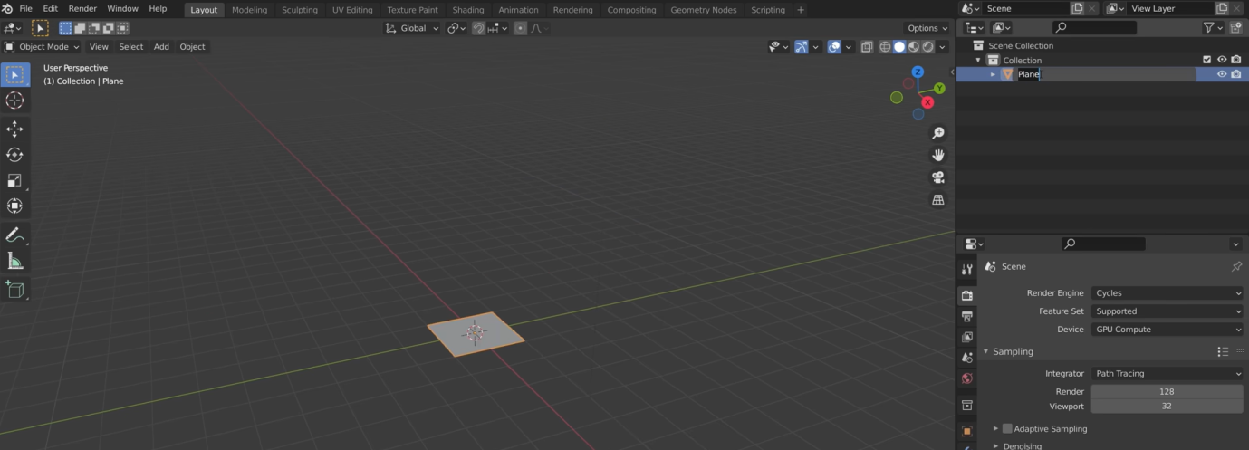  
Merge vertices to center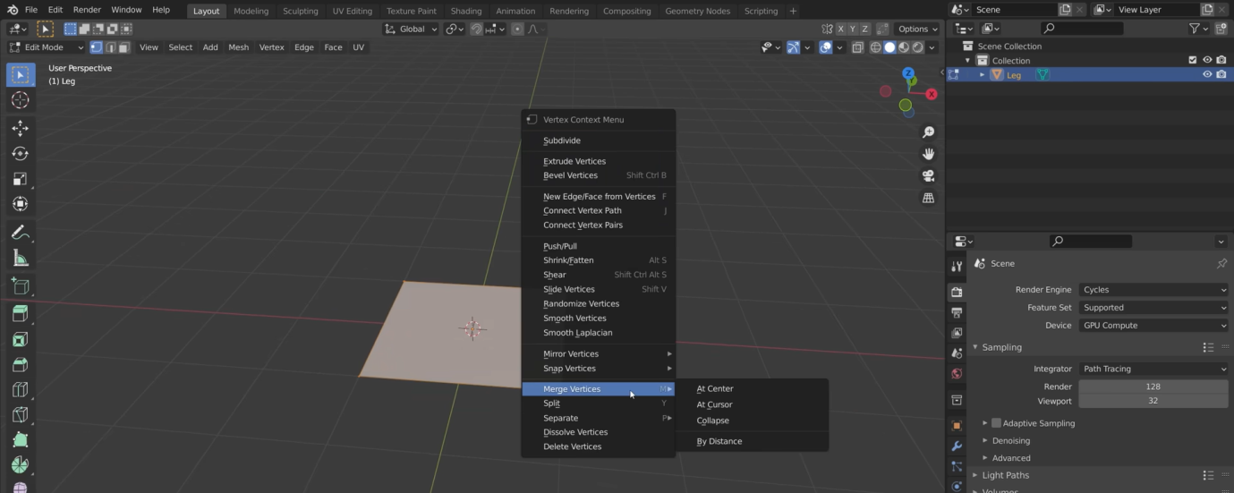  
Extrude it up to 4 meter**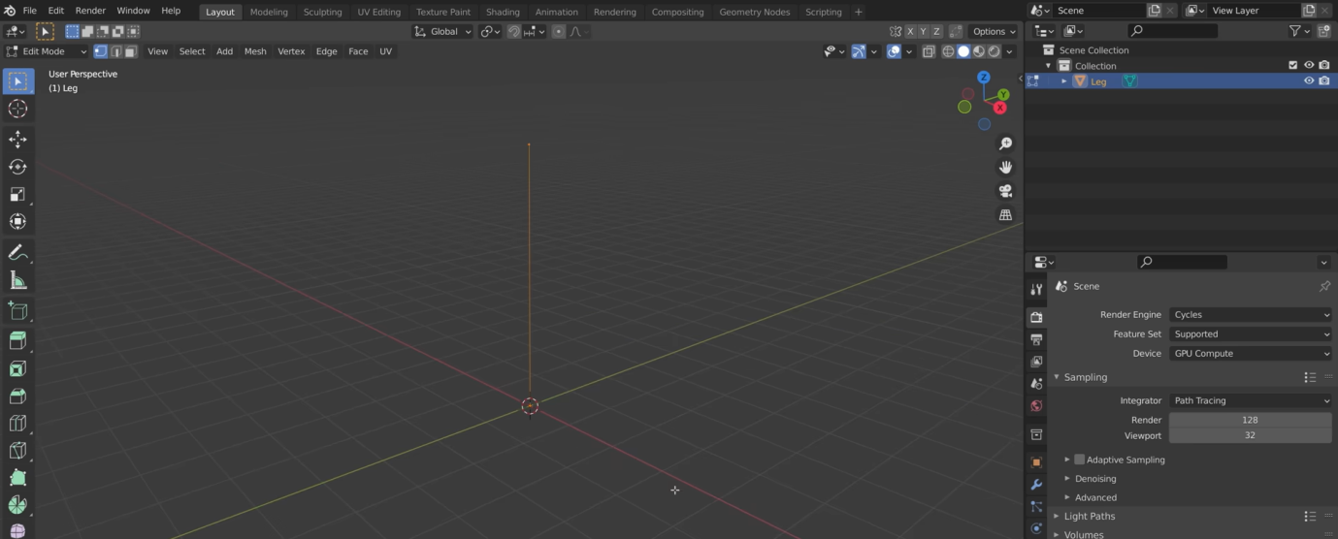

**Add skin modifier**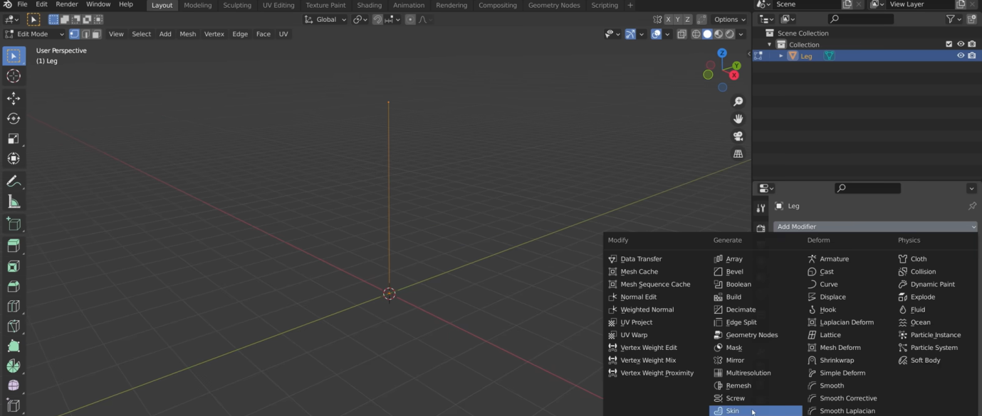

**Rectangle with skin modifier**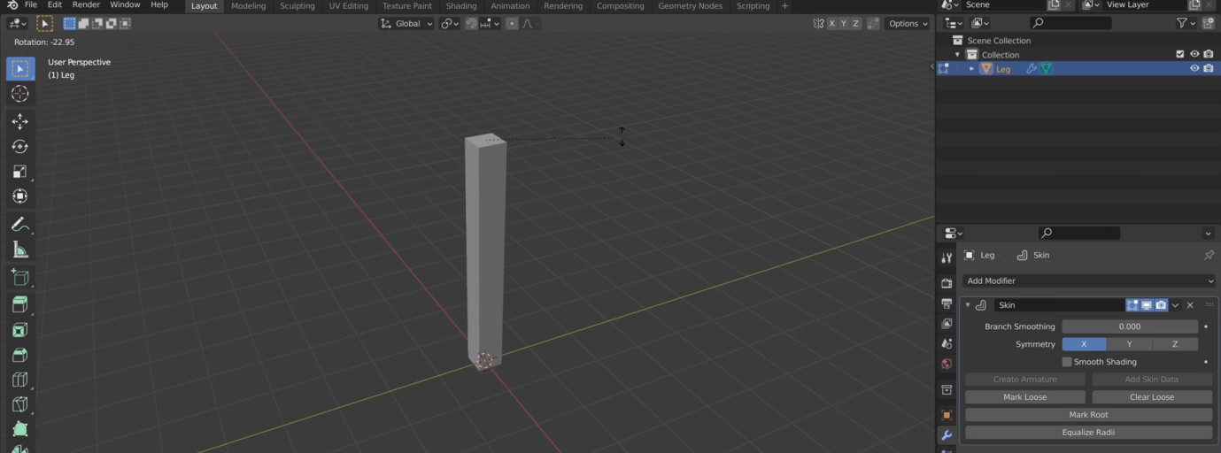

**Giving pyramid shape**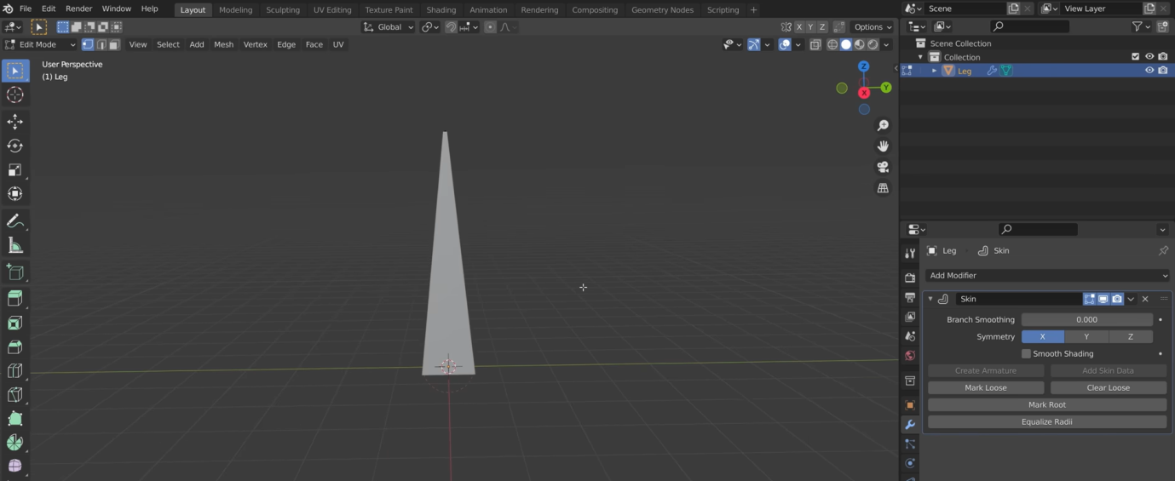

**First step :  
Modelling the leg**

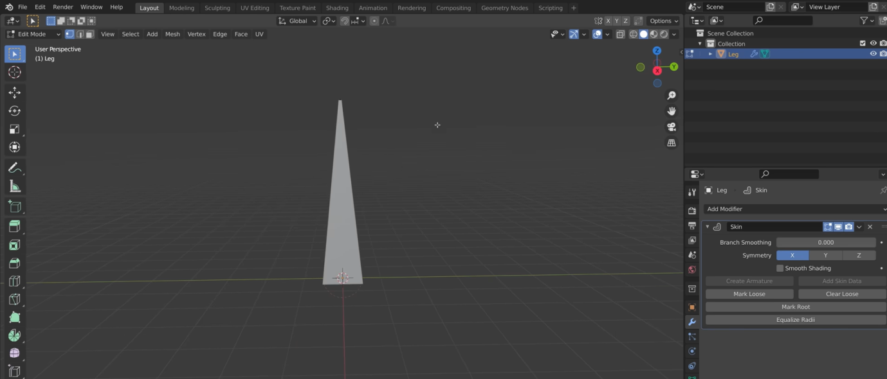

**Second step:  
Setting up IK rigs**

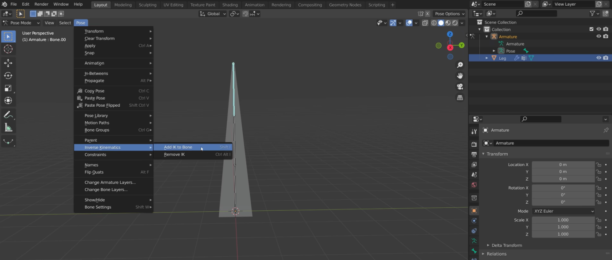

**Third step:  
Creating the body using scripts  
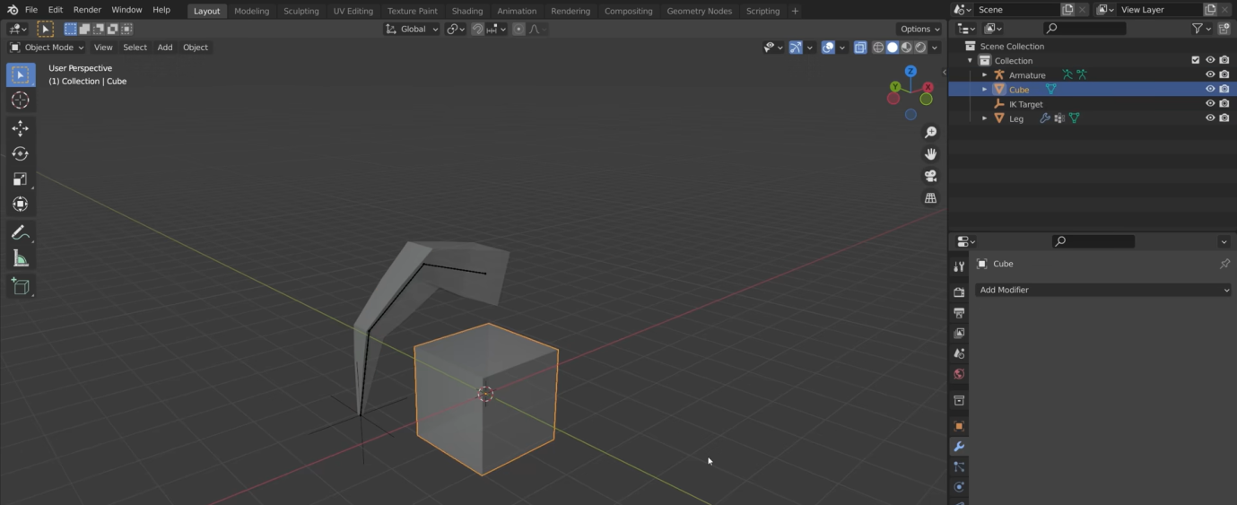  
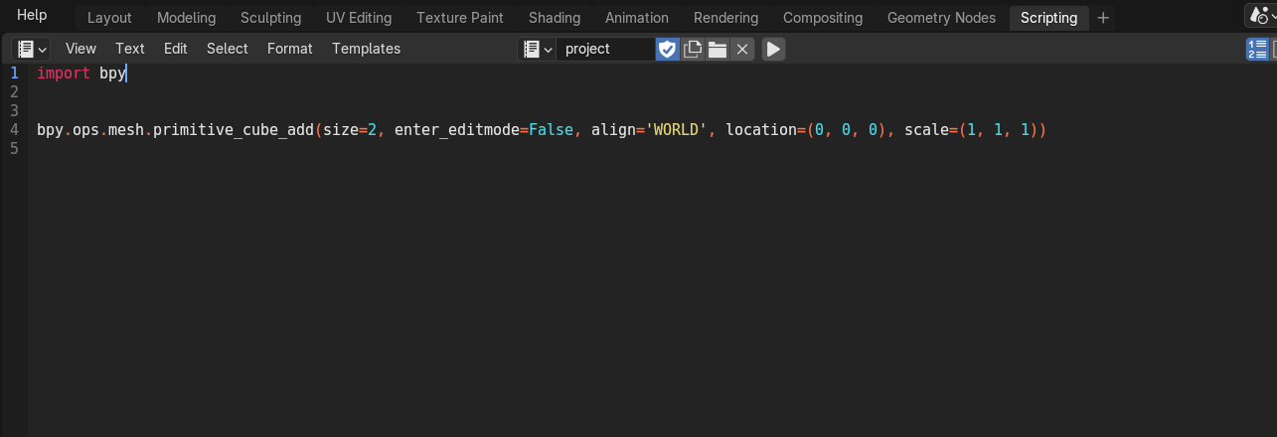  
Fourth Step:  
Making ico-sphere for joints using scripts  
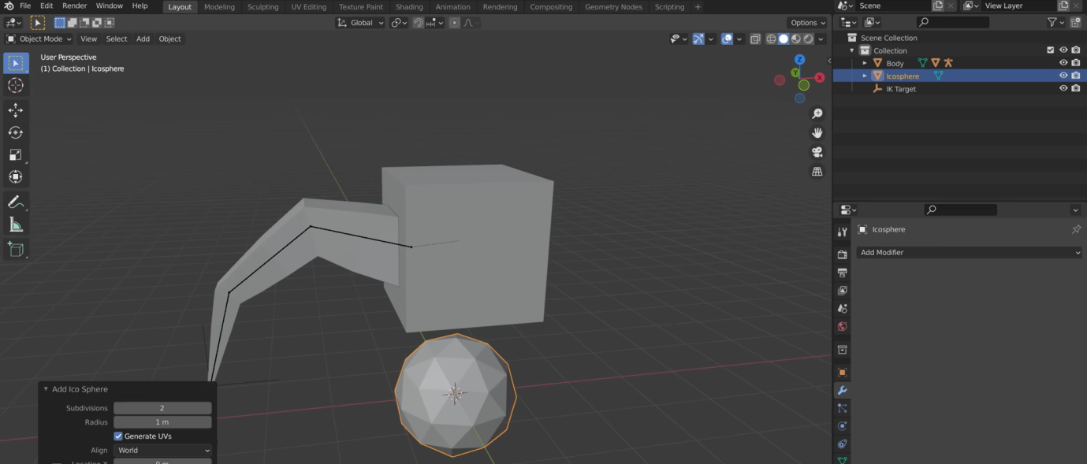**

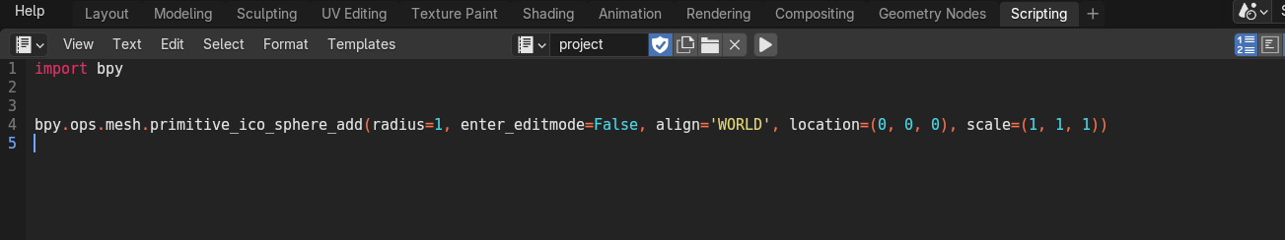

**Fifth step:  
Creating the motion path by Besizre Circle  
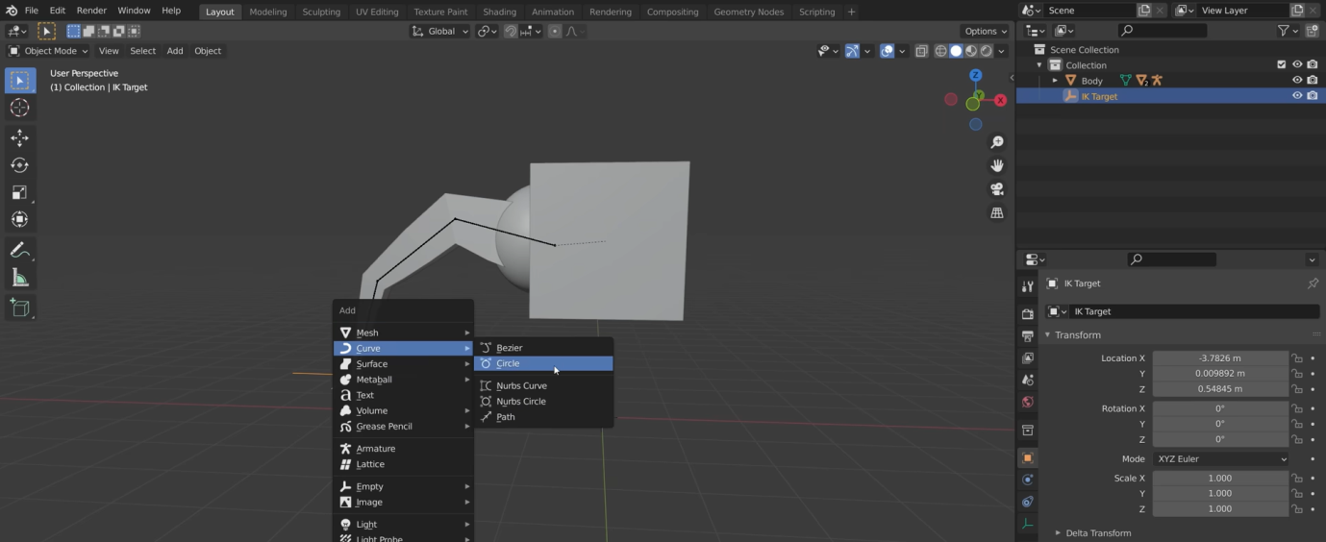**

**follow path setting**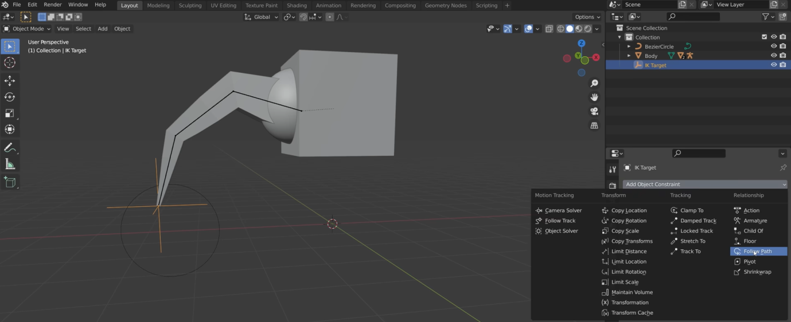

**Sixth step:  
Making the motion path to Semi circle to make it more realistic**

**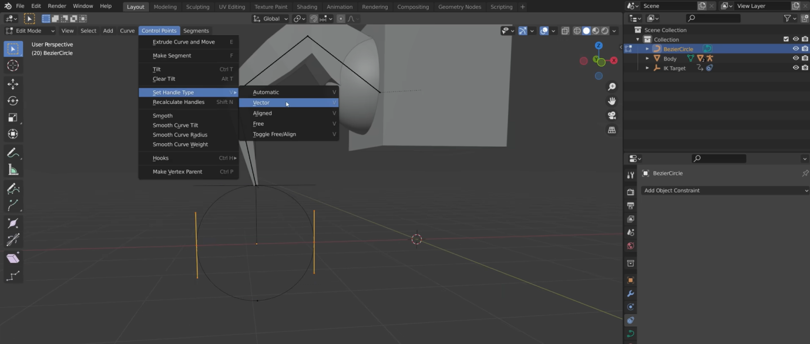  
Seventh Step:  
Animating the leg**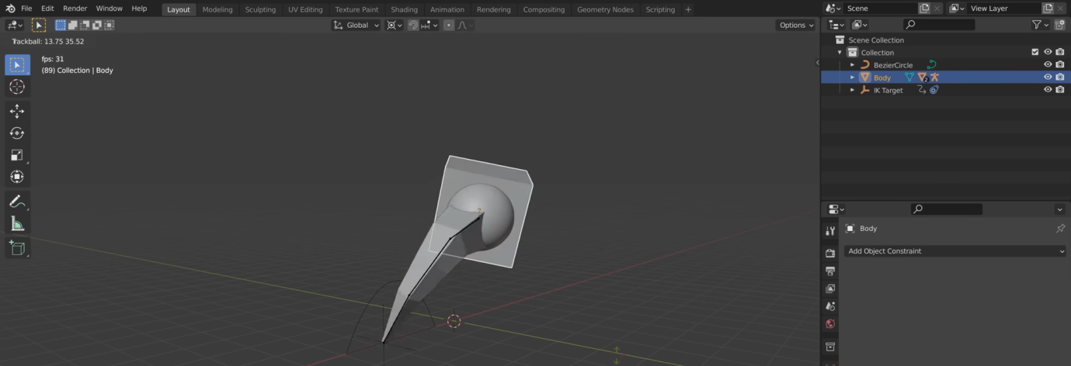

**Eight Step:  
Duplicating the leg by Shift D then R by 90 degree**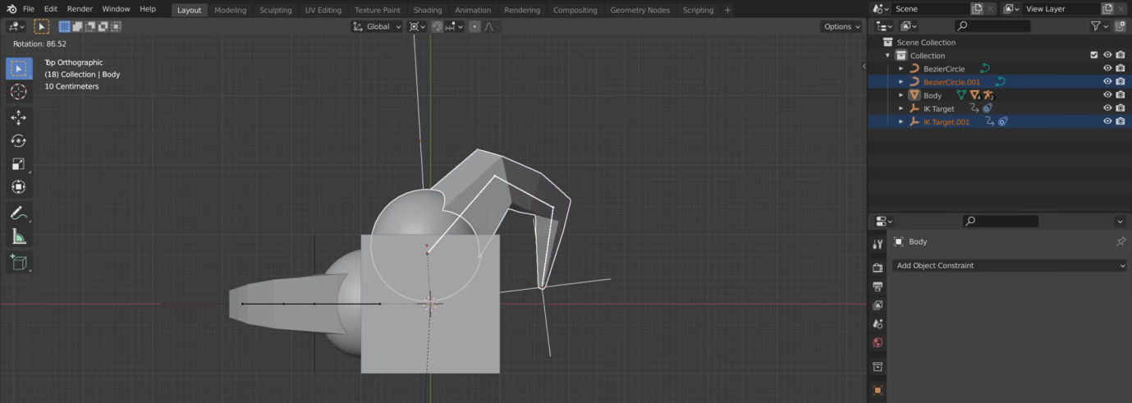

**Ninth step:**

**Creating two more legs by Shift R twice**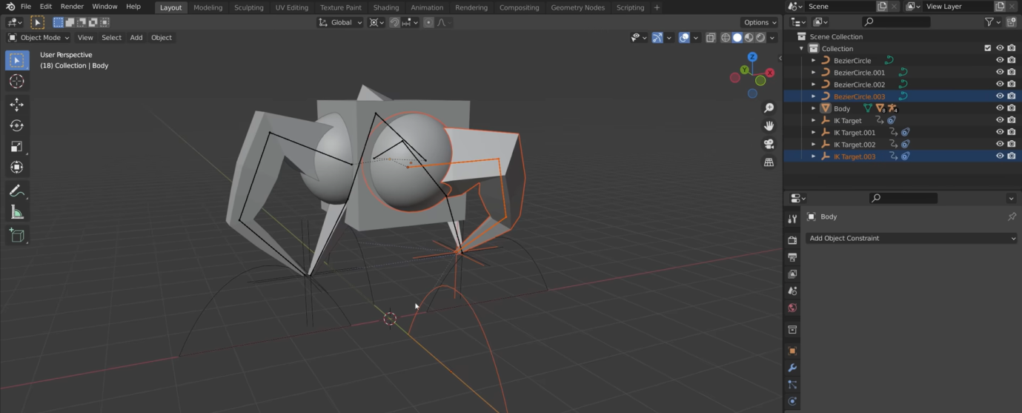

**10th Step:**

**setting the pivot point to individual origin**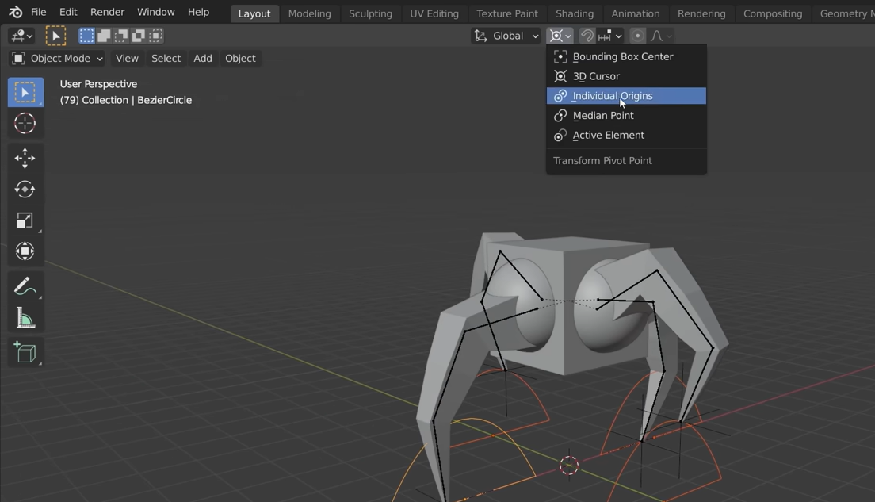

**11th Step:**

**Direction controller Set up**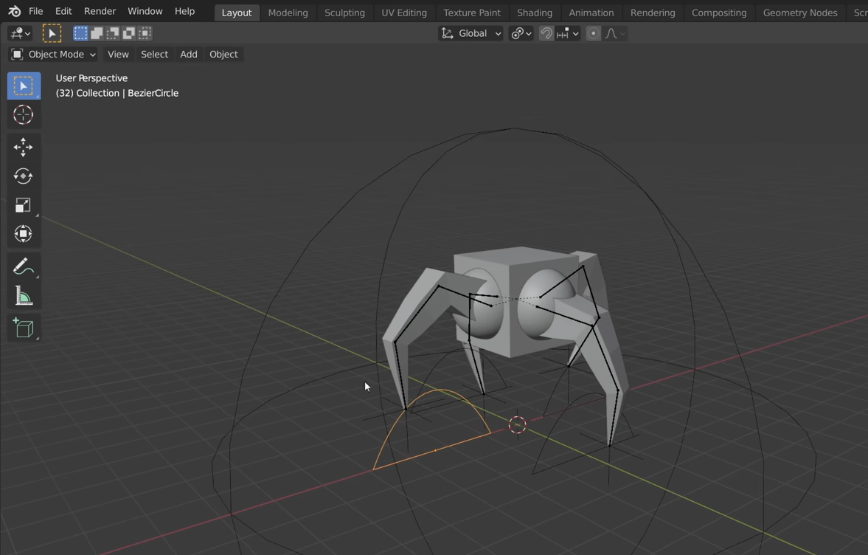

**12th Step :  
Change the editor type to Graph Editor and add location and rotation keyframe**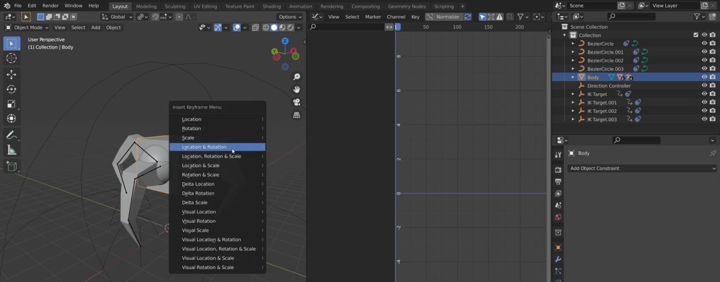

**13th Step:  
Adding random movement by using noise modifier**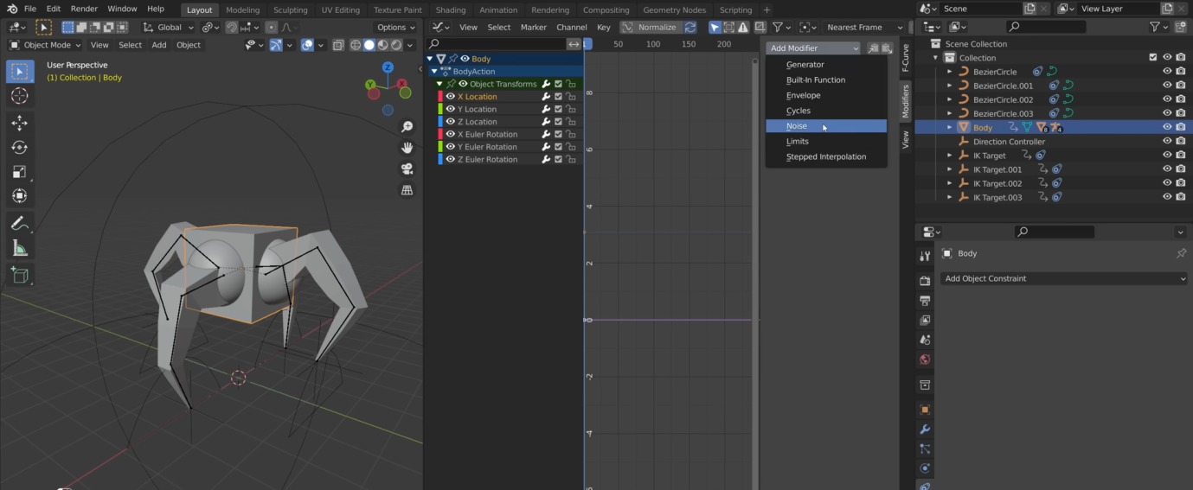

**I added random movement in X location , Z location , X rotation and Z rotation to make it ogranic.**

**14th Step:  
Creating chracter controller**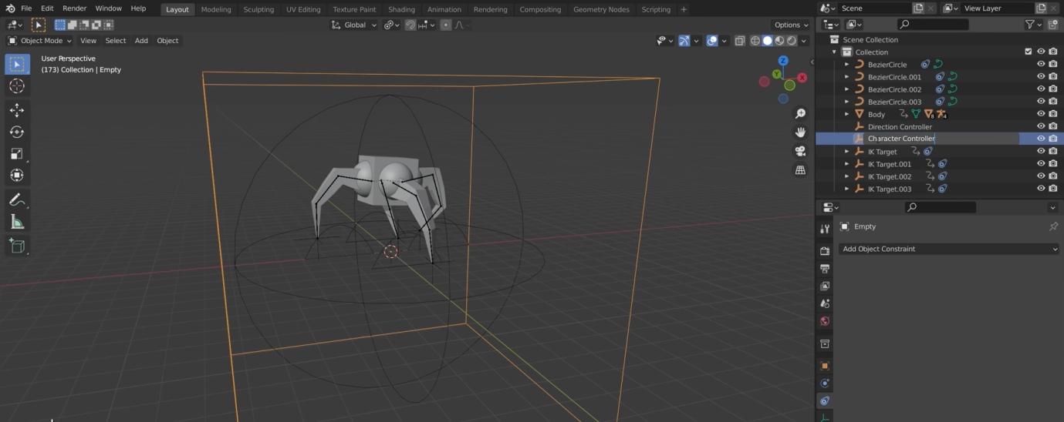

**15th Step:  
Walking across the screen using key frame technique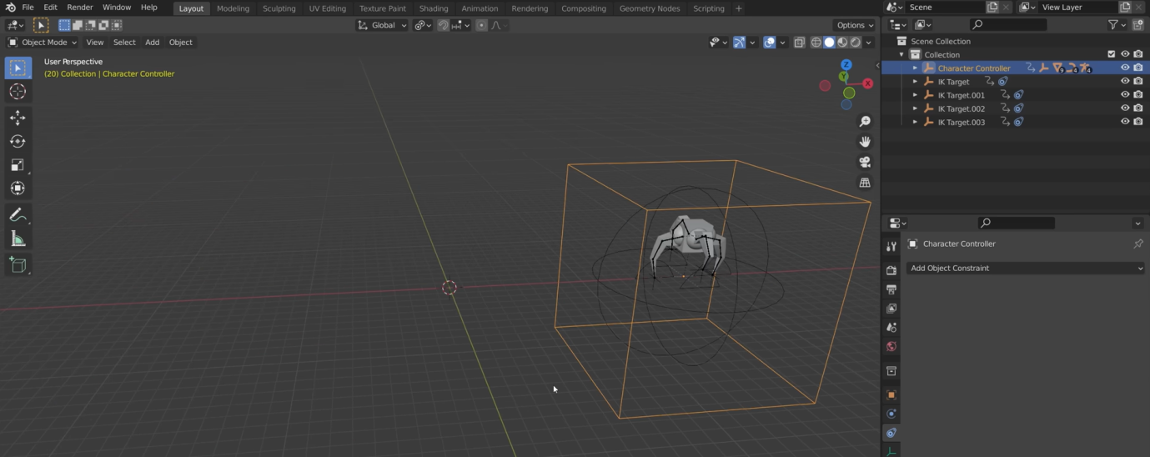  
  
inserting keyframe by using i**

**16th Step:  
adding sine curve to Z location to make it more realistic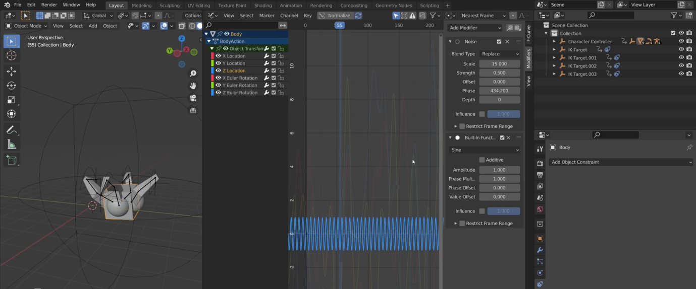  
and change the values accordingly**

**adding body material to body** 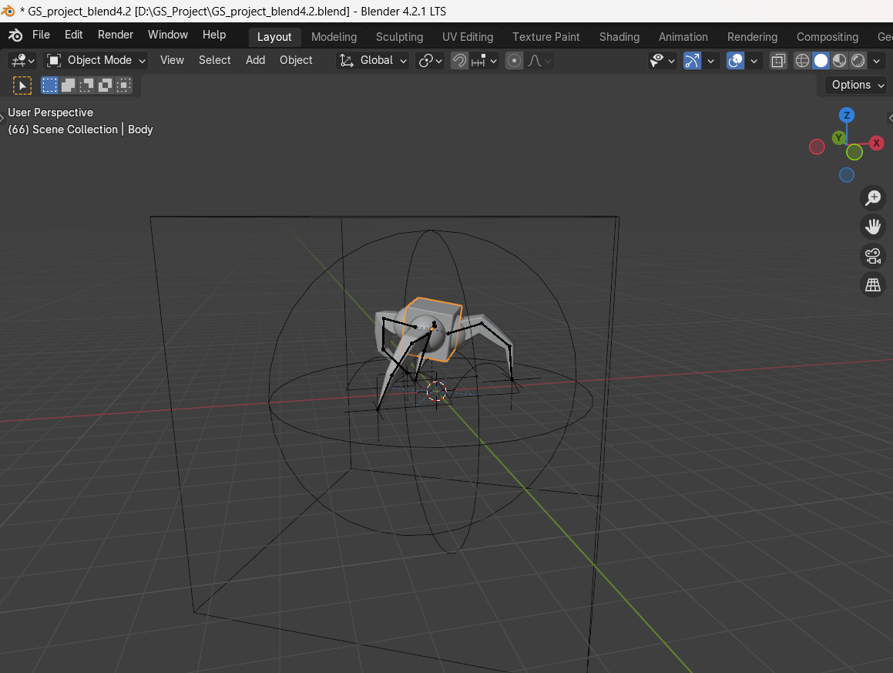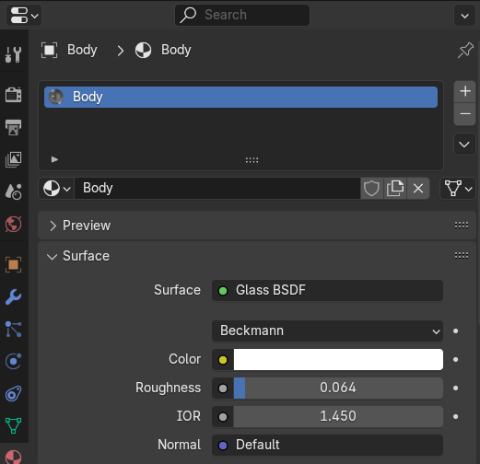

**Adding joint material to joints**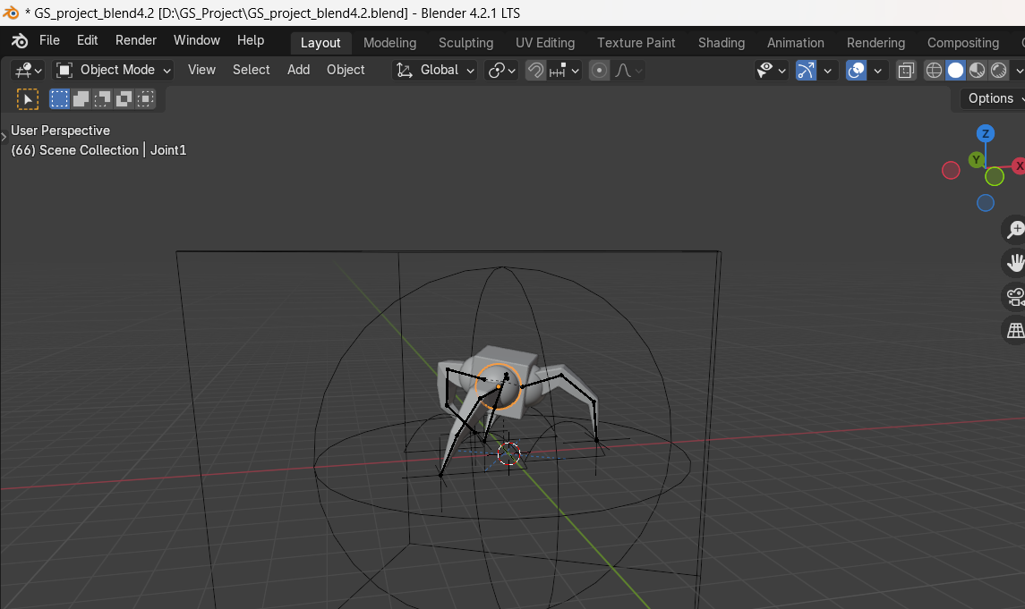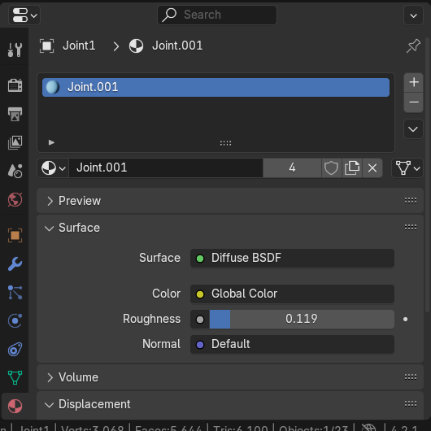

**Adding leg material to leg**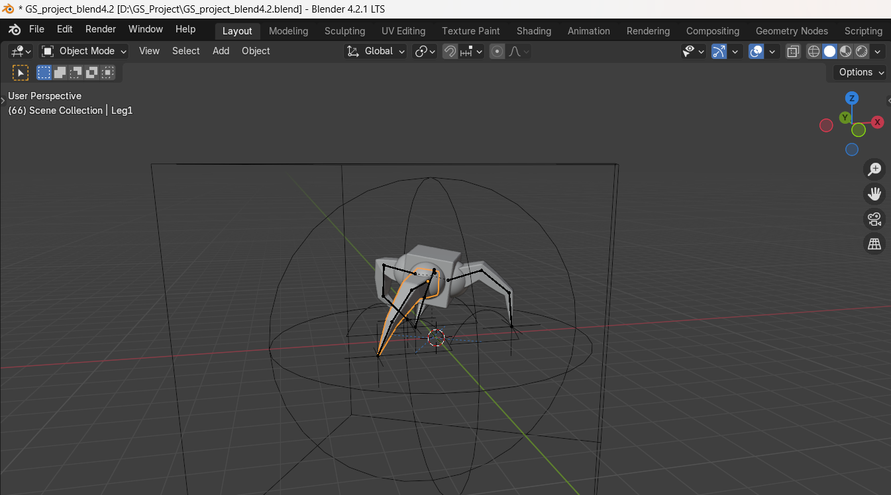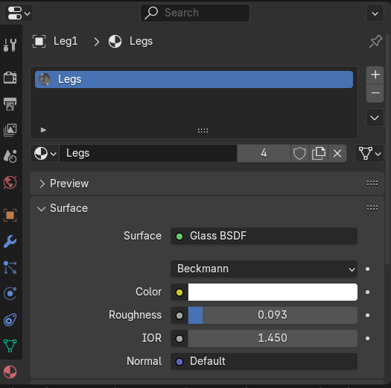

**17th Step:  
Creating the mirror Objects**

**creating mirror plane**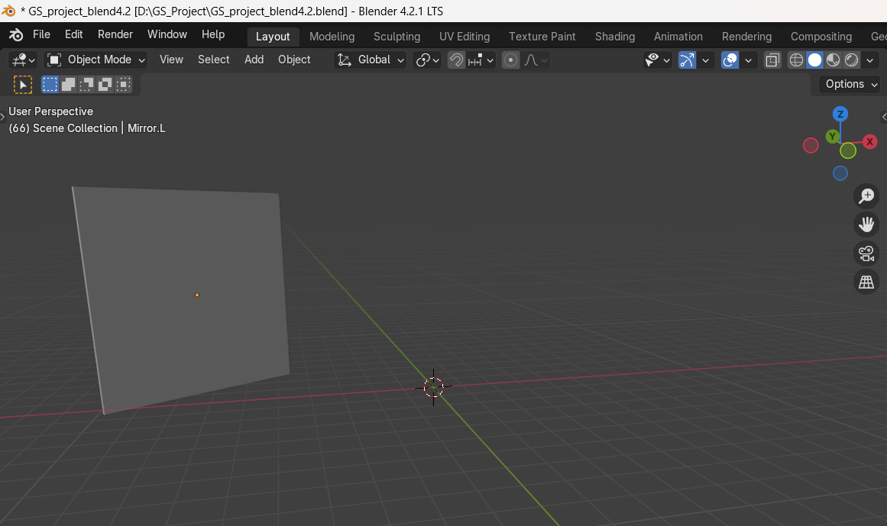

**Creating mirror frame**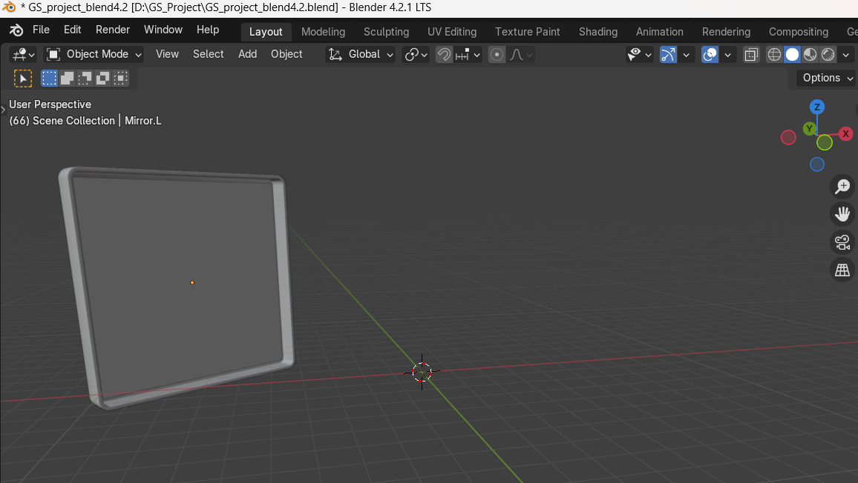

**Creating mirror stand**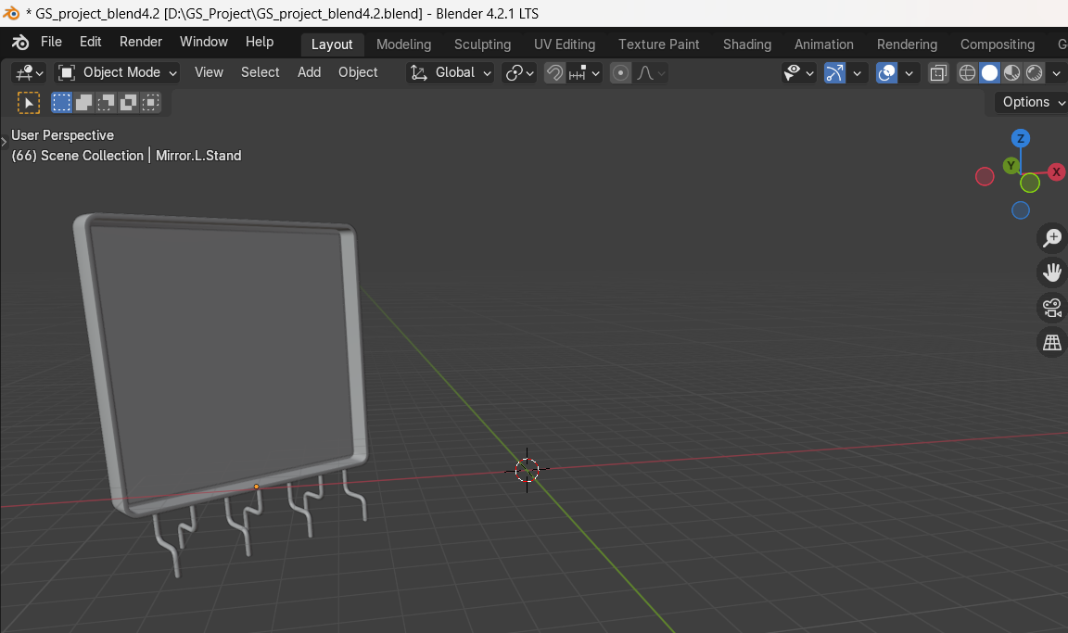

**creating mirror stand buttons**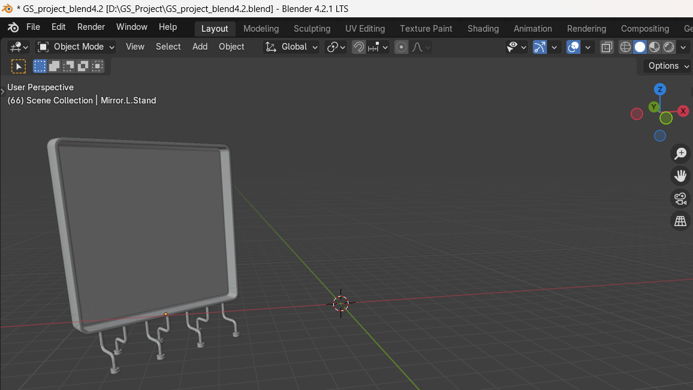

**Control D duplicating mirror Objects** 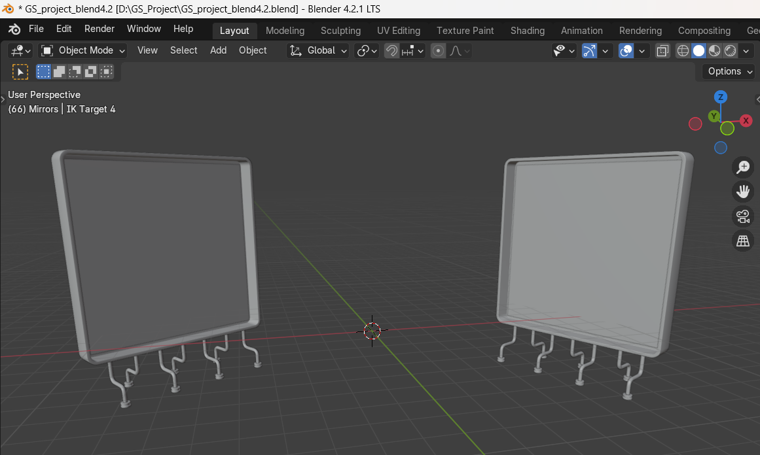

**Adding mirror material**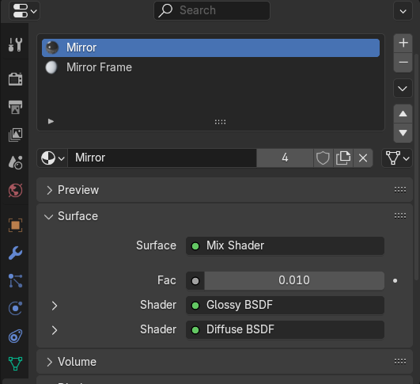

**Adding mirror frame materials:** 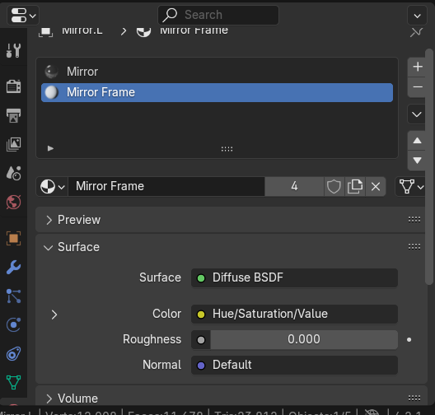

**Adding metal to the stand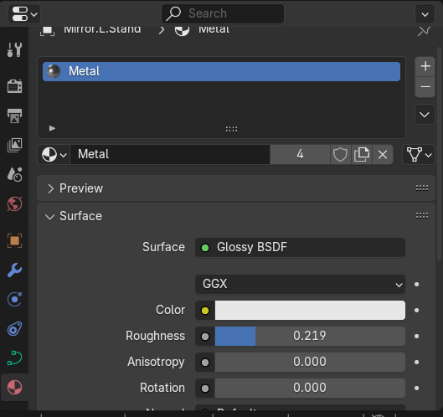  
  
Adding secondary color to the stand button**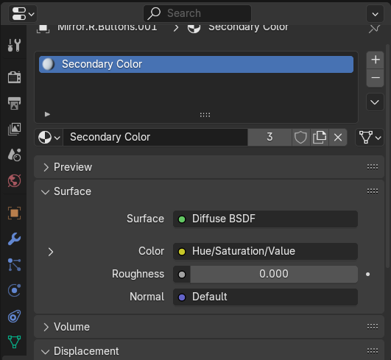

**18th Step:  
Adding mirror controller**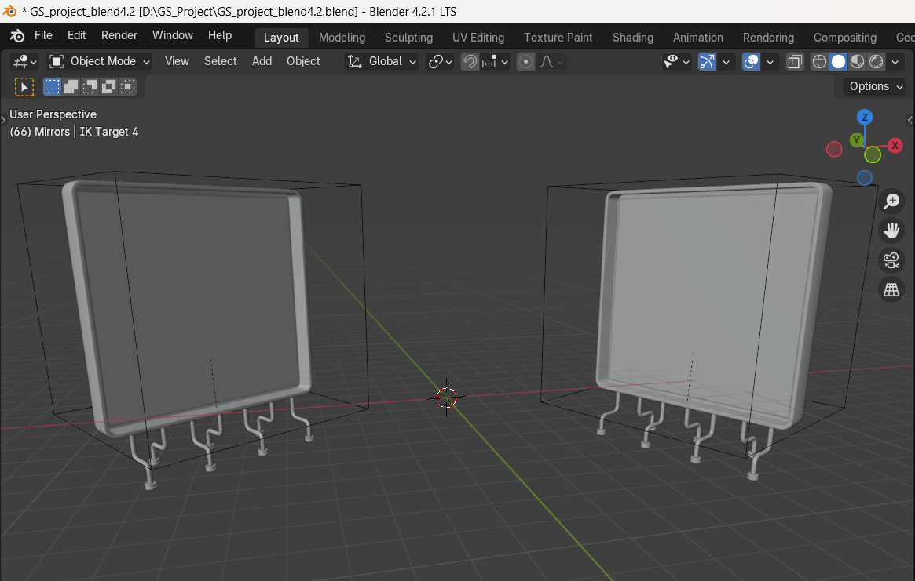

**19th step:**

**creating the attachment for Belt rig**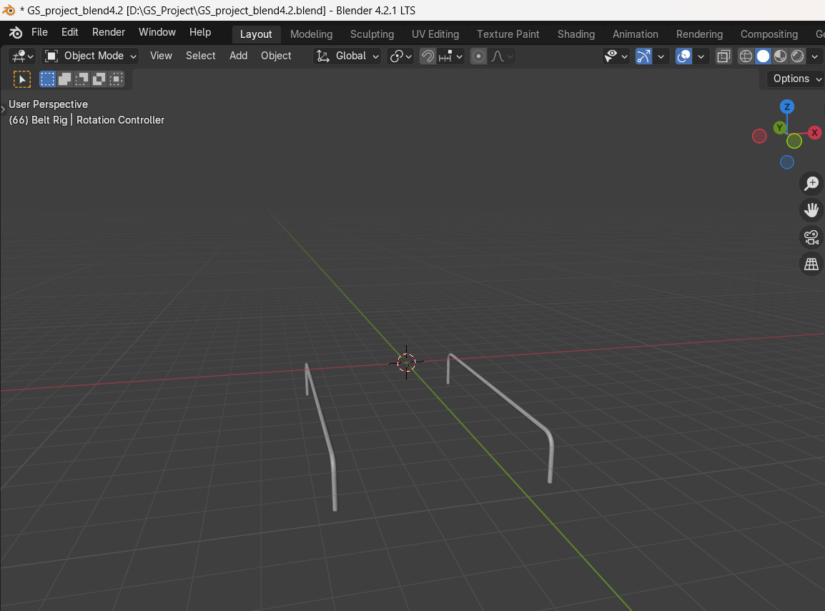

**20th Step:  
Adding right cog wheel**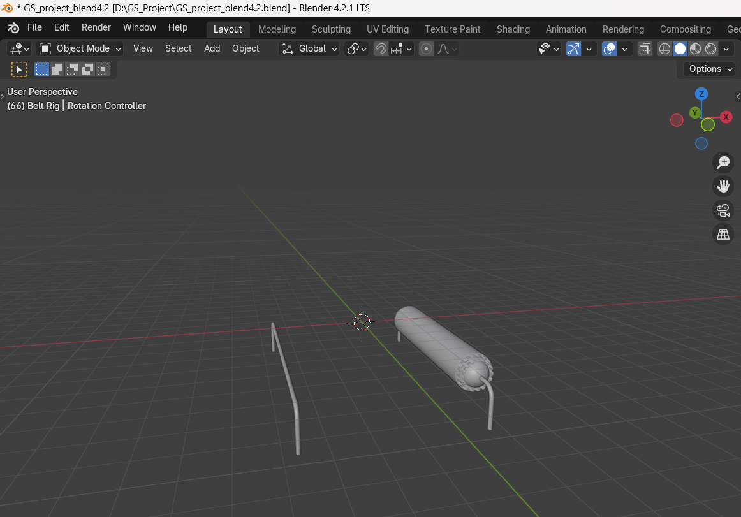

**21th step:  
Adding left cog wheel**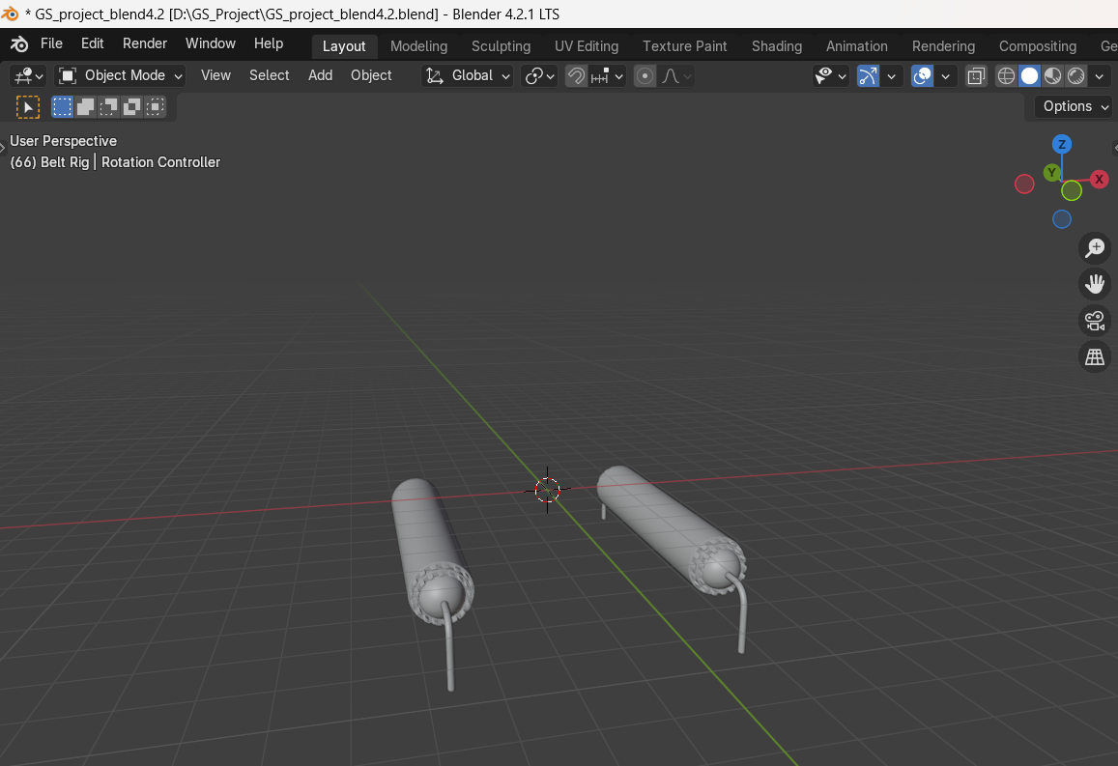

**22nd step:  
adding belt leg knobs**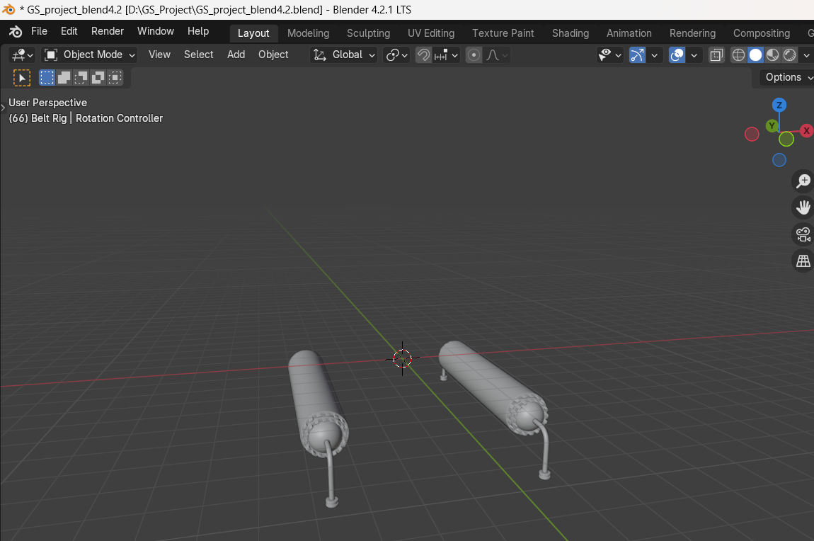

**23rd step:  
adding the belt**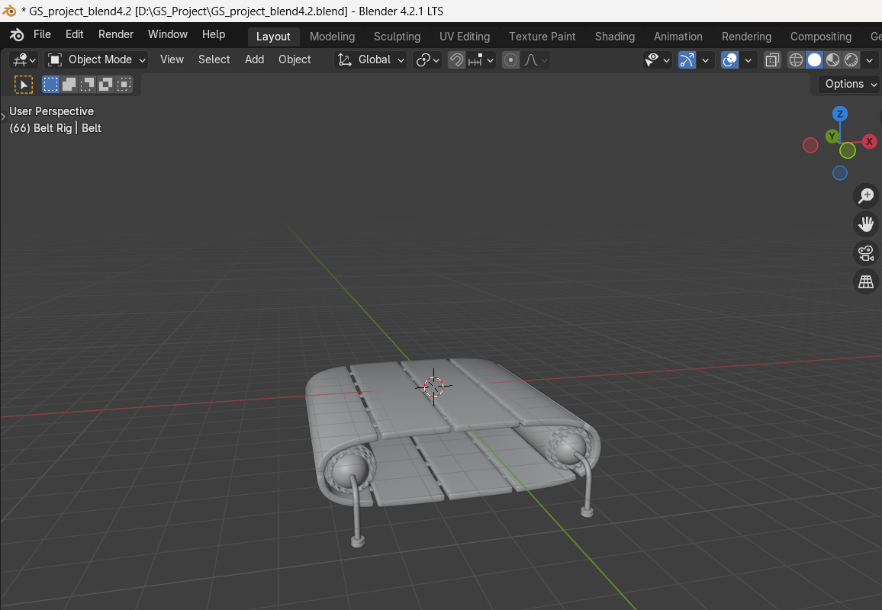

**24th step:  
adding rotation controller**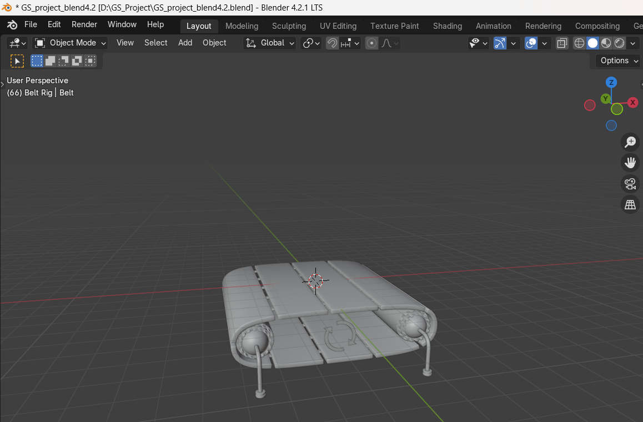

**25th step:  
adding belt material to belt** 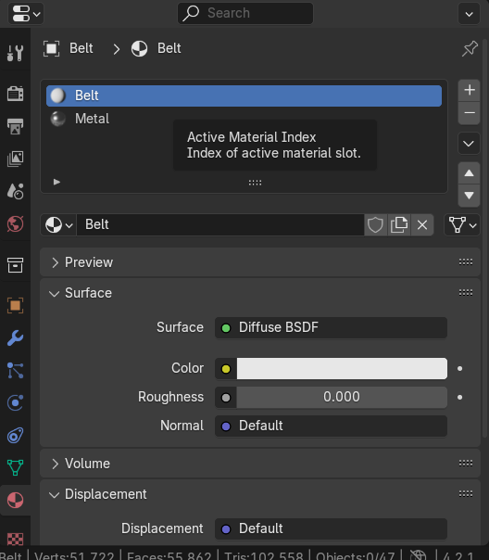

**26th step:  
adding secondary color to belt leg knobs**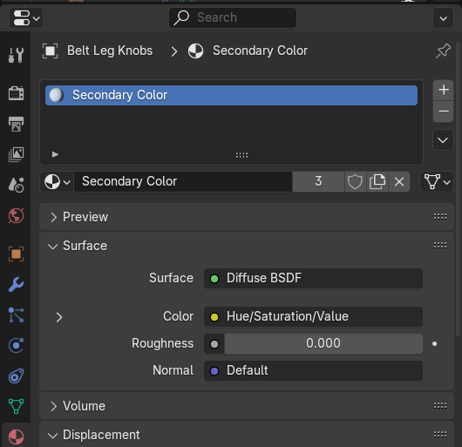

**27th step:  
Adding material to cog wheel**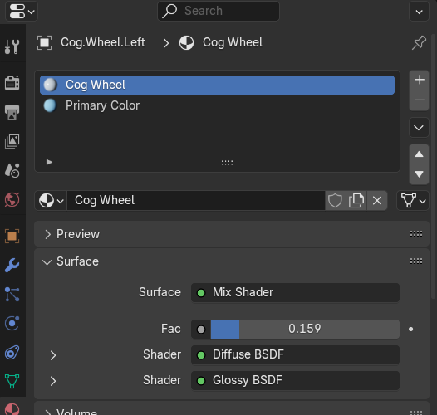

**28th steps:  
adding metal material to stand**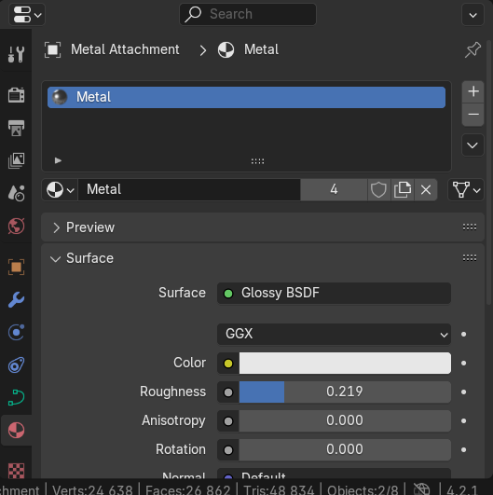

**29th step:  
adding ground to the environment**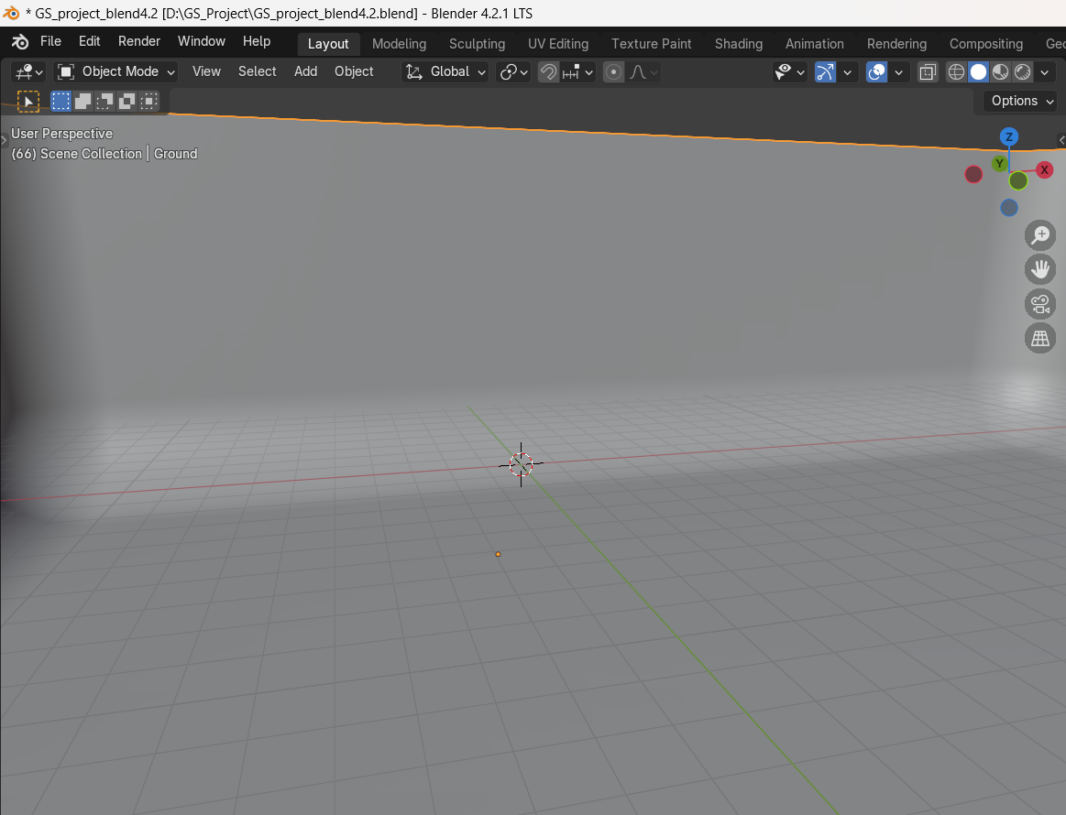

**30th step:  
Adding camera rig to it**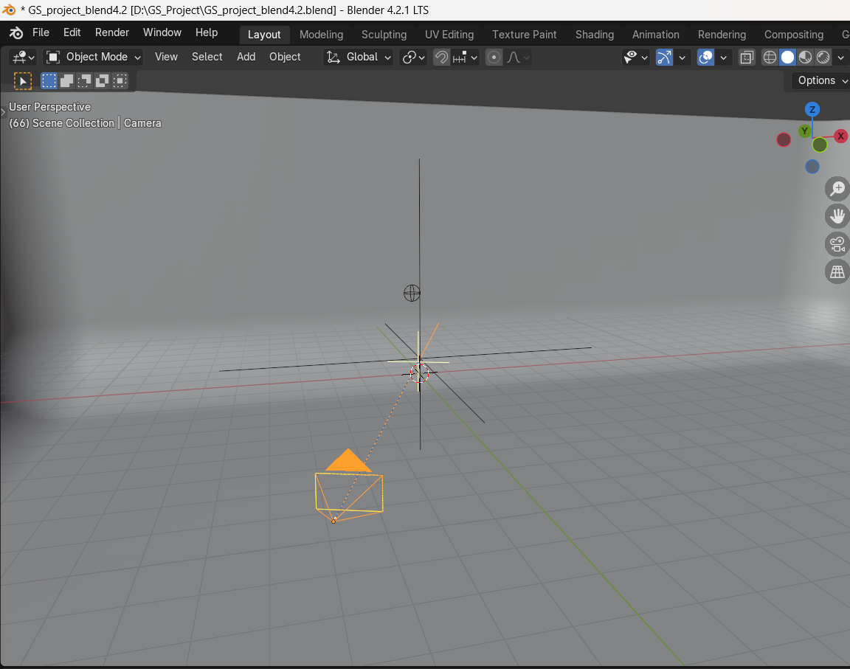

**adding backdrop materials to background**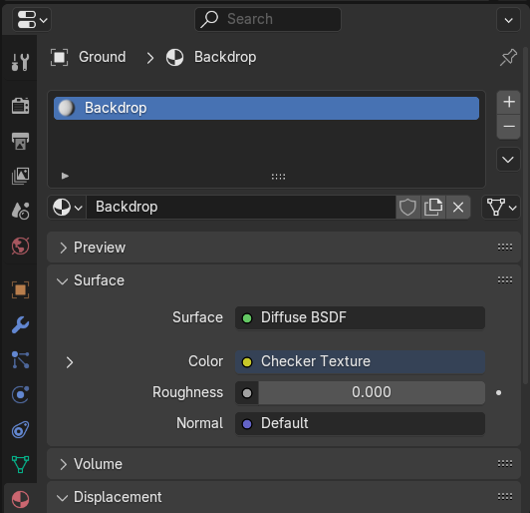

**31st step:  
fixing the focus**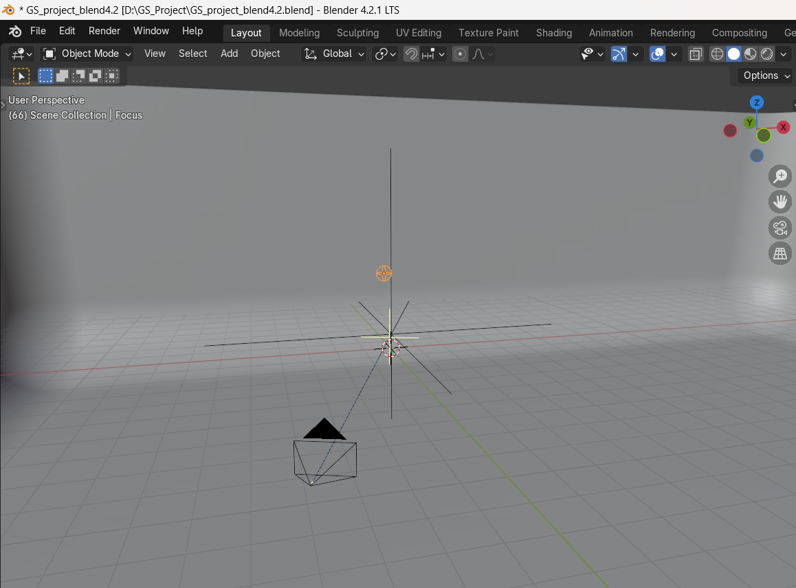

**32nd step:  
Adding a area light**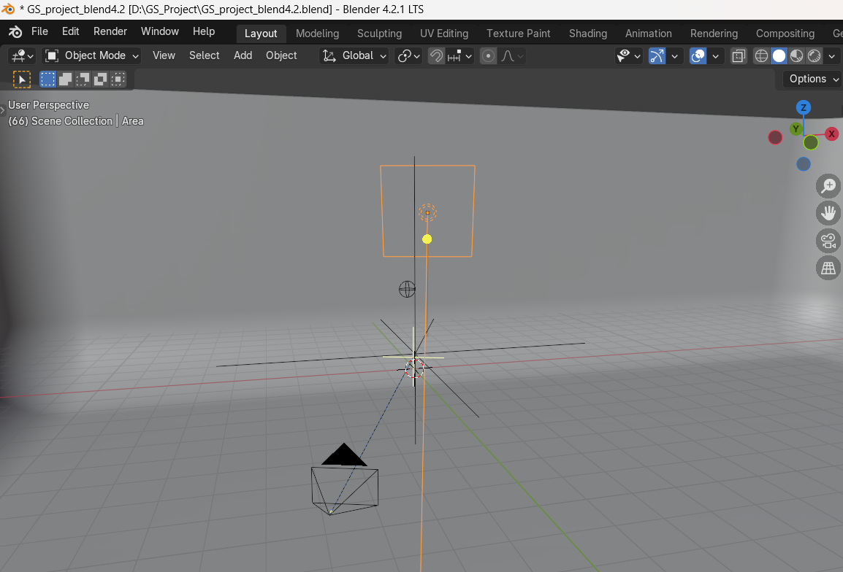

**33rd step:  
adding a left light**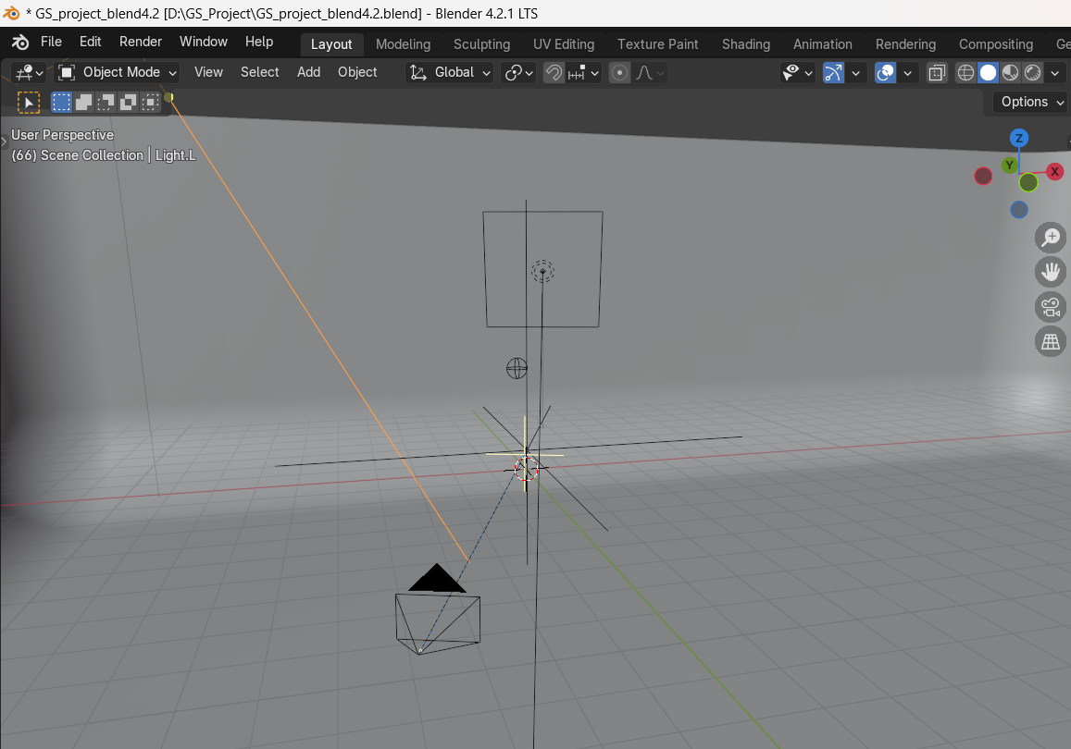

**34th step:  
adding a main light**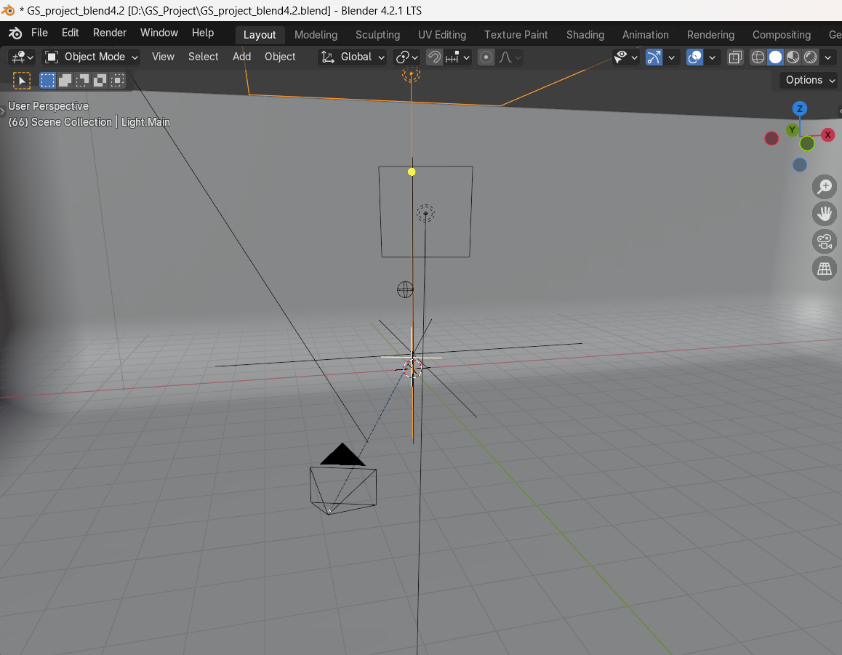

**35th step:**

**adding a right light**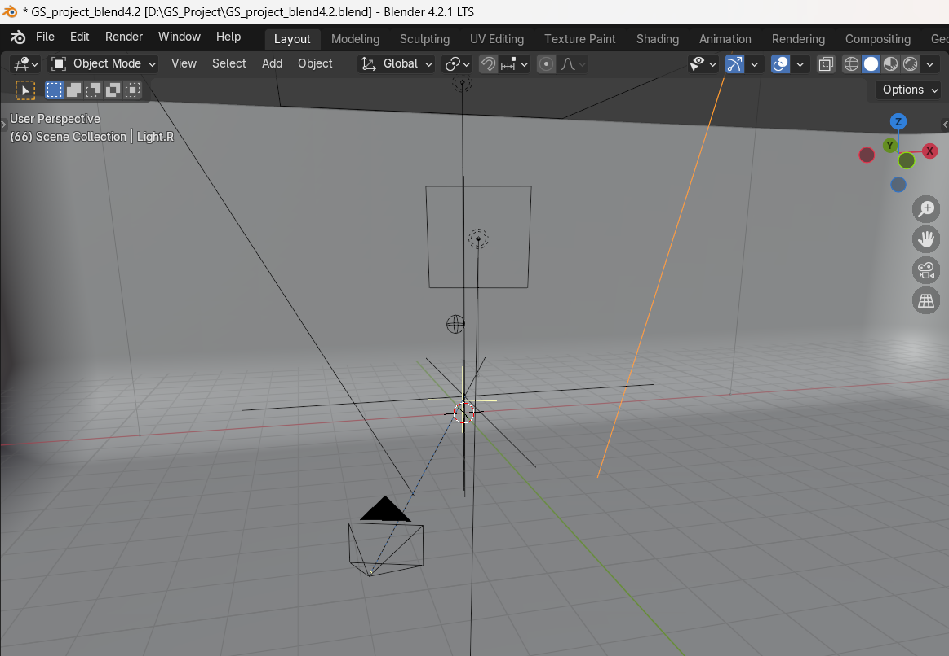

**The scene consists of a studio lighting setup, a global color controller (top right corner), a glow compositor setup, a treadmill rig and the tutorial character.**

**The character is the same as but with added glass material on the body and legs, and diffuse material on the joints. There is also some subtle bevel used to create more interesting reflections in the materials.**

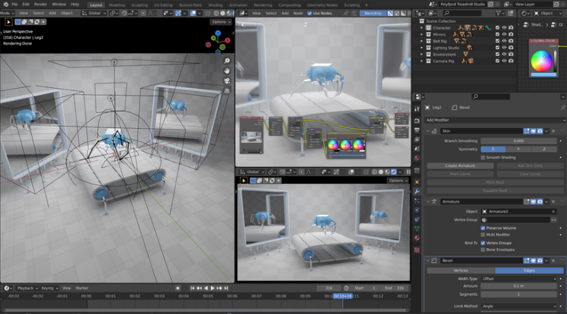

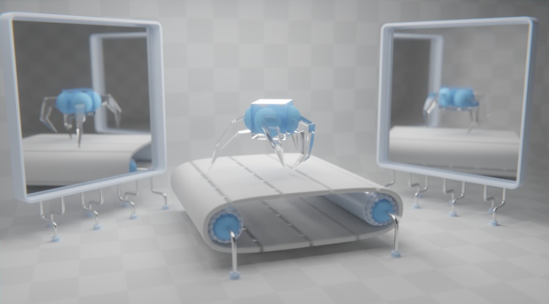

**The mirrors are simply two planes with a glossy material setting roughness almost to 0.**

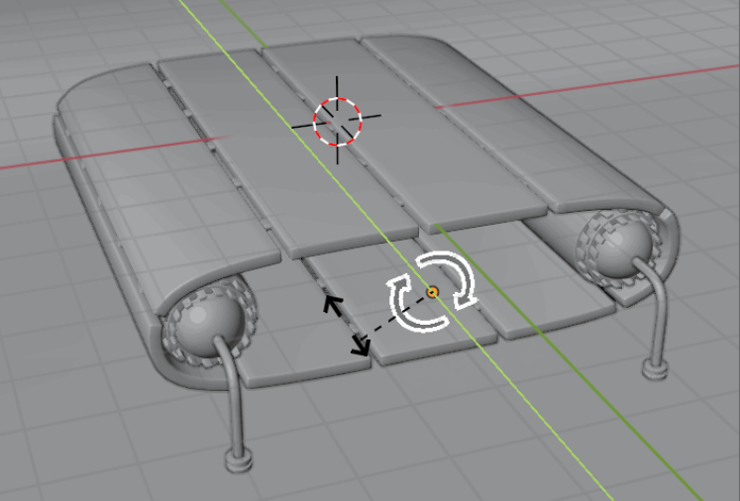

**The animated treadmill is rigged with drivers and can be synced to any walk speed! Perfect for practicing walk cycle animations!**

**The end of my project**